

ACTIVITY 1 : SELF CHECK
1. What is the difference of intramurals from extramurals ?
The difference between these two that intramulars particularly from schools where in one institution, or within the walls. Meanwhile extramulars take place outside of the walls of an instituton.
2. What are the things you need to consider in organizing an intramulars ?
In preparing for an intramulars, I will consider a healthy competition that ensures a welcoming environment, and the organization of each schedules, team formations, and the condition of their equipment.
3. Why is it important for intramulars to be part of the yearly school activities ?
It is important to test the sportsmanship, talent, and creativity of the students nurturing one of them in our society, to be capable in their future or chosen professions.
In addition, it teaches them how to be more responsible, and being able to handle problems, making the right decisions.
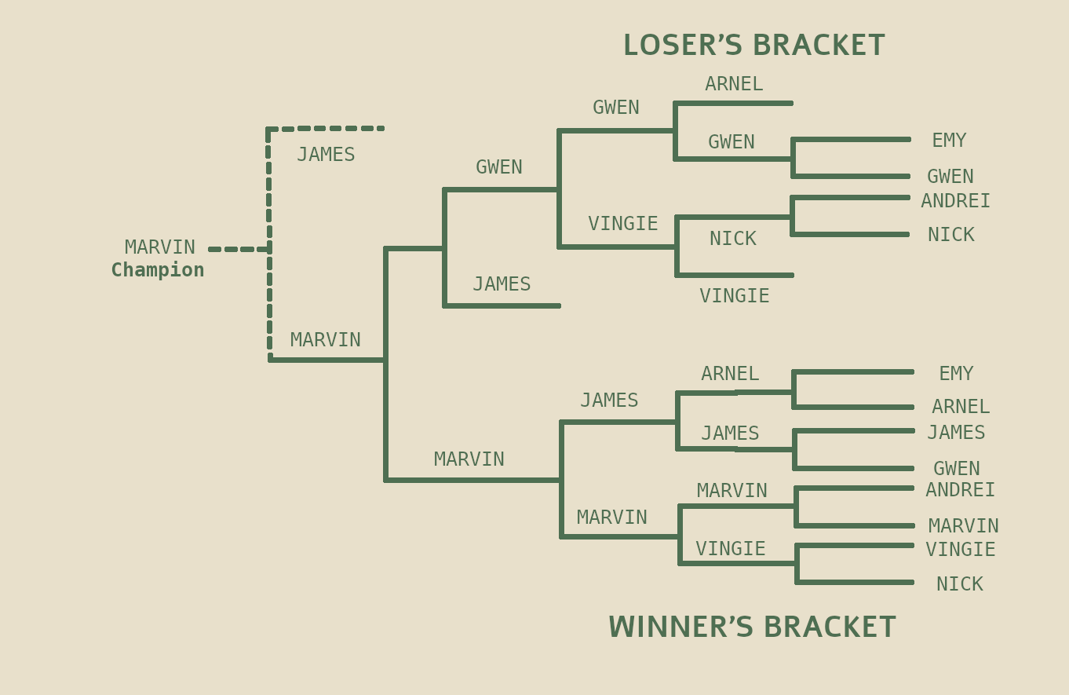
ACTIVITY 2 : TOURNAMENT
“ENHS CUP CHESS TOURNAMENT “

